Unreal Tournament Importation of 3d Models
By Carolyn Brooks

I Creation of Models via 3d Studio Max
- Modeling constraints
- Exportation of static model
c. Exportation of animated model

II 3ds2unr Software Importation
- File organization
- Texture format conversion
- Scripting 3ds2unr file output

III Importation from 3ds2unr into Unreal Ed
- Scripting file compilation
- Compilation of 3ds2unr file via Unreal Engine
- Reference to imported file in Unreal Editor

I Creation of Models via 3ds Studio Max

All the models that required importation via the 3ds2unr pipeline (not including .DXF files that may be directly imported into Unreal Ed) models where created and animated in 3d Studio Max (3ds Max). 3ds Max enables for many forms of animation and creation of meshes. Unreal Ed only accepts a small number of options that are available to the artist in 3ds Max. The primary stipulations that must be adhered to are as follows for static models:
- All models must be ONE mesh, and ONE element. For example, the coyote is ONE mesh, ONE element (select element by chooses figure via Edit Mesh>Element; red cube icon). The two spheres are one mesh (the spheres have been Edit Mesh >Attached) however; they are not one element because entire mesh is not highlighted. 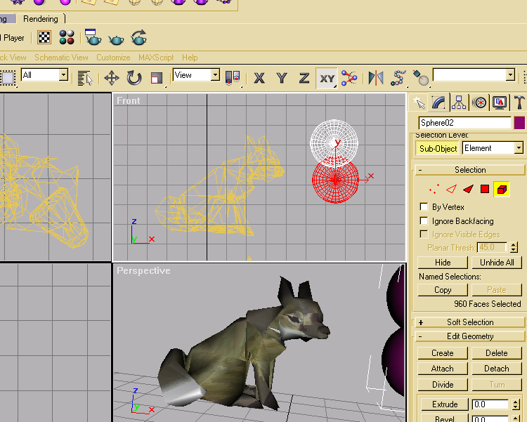

Fig 1. Spheres are NOT one element, one mesh

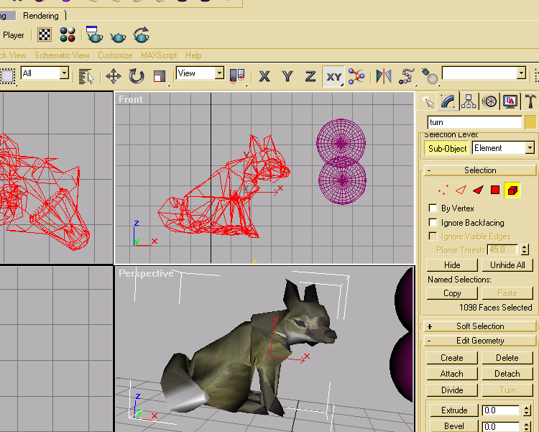
Fig 2. Coyote is one element, one mesh

- All animations and models are constrained 256 X256 X 256 coordinates. This means that not models can have vertices outside of this 256 bounding box (ensure that mesh is contained inside grid of –128 to 128 on all axes).

- The importation of models does allow for all forms of texture mapping, but the texture must be square with the power of 2 sizes. For example, the most common texture map was 256 by 256 pixels. The largest texture map can be 512 by 512 in size.

- Only one mesh may be exported at a time.

- Other exportation formats are available, for example .DXF, (which does not adhere to the same limitations and can be imported directly. However, all texturing must be done in Unreal Editor, and no animations are imported with mesh), but .3DS is the format that should be used for importation of textured static models. BEFORE EXPORTED make sure that one mesh has a name that ends with a 01. For example, below the mesh title for the coyote has been changed from to ‘coyote01’. 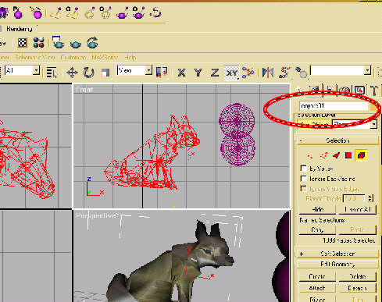
Fig 3. Name of mesh has changed.

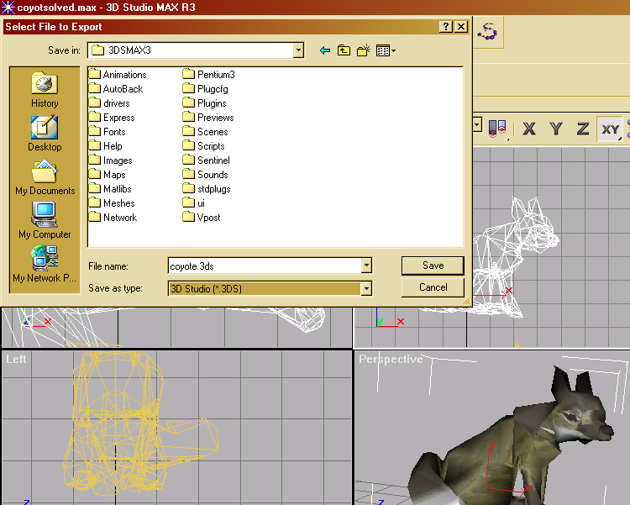
Fig 4. Export one mesh as .3DS

The exportation of an animated model is slightly more involved. All the stipulations required for a successful importation of a static model must be adhered to (refer to bulleted notes above).
- The animations can be as high as 700 frames.
- The title of mesh to import must NOT end in a number (this is because a series of snapshots will follow that will automatically number the title.) When the model is ready to import, select the mesh and go to Tools >Snapshot and make a snapshot of the animation. Hint: Save work before snapshots are created. Appropriately, the fields for ‘To’ and ‘Copies:’ must equal the number of frames in your animation. Keep all other fields as below: 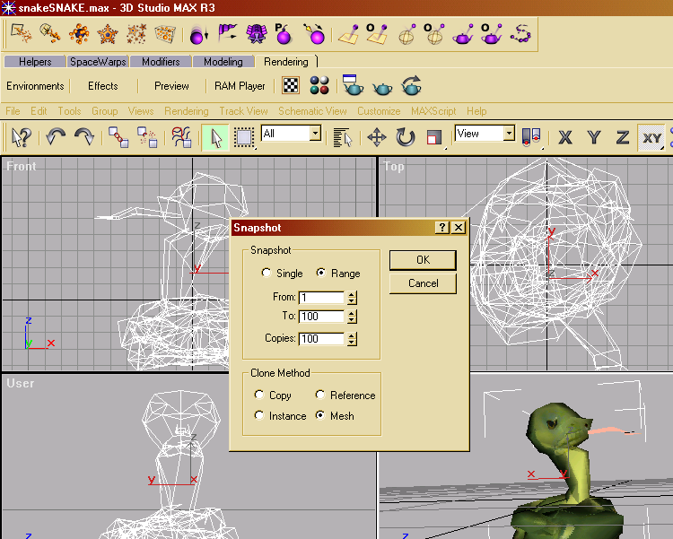
Fig 5. Tools>Snapshot with mesh selected

- Delete original mesh by pressing delete immediately after snapshot process has completed. If impatience has resulted in original mesh no longer being selected, refer to ‘Playlist’ button.

Now export the file as .3DS as before with a static model.

II 3ds2unr Software Importation

The software that enables for the .3DS file to be imported correctly into Unreal Editor is a free software package that can easily be found online called 3ds2Unr.exe. I found the software on www.planetunreal.com.

The software requires a sophisticated organization of files. In the Unreal Tournament folder create a folder with the name of the mesh you exported. For example, if someone just exported coyote.3DS, that individual should create a folder entitled ‘coyote’ in the Unreal Tournament folder. Inside this folder, create two folders entitled,’ Classes,’ and ‘Models’.

The texture files used in the 3dsMax model must be manually converted to .pcx format, indexed (8 bit). The converted texture file must be named as the mesh name with a digit appended. For example, the texture map created for coyote mesh, is converted to proper format and named coyote1.pcx. Place this texture file in ‘Models’ folder. If more than one texture map is used for a model (maximum number of textures for one model are 7), each subsequent material (following the number sequence of the 3dsMax Material Editor) must be numbered chronologically and placed into ‘Models’ folder as well after conversion.
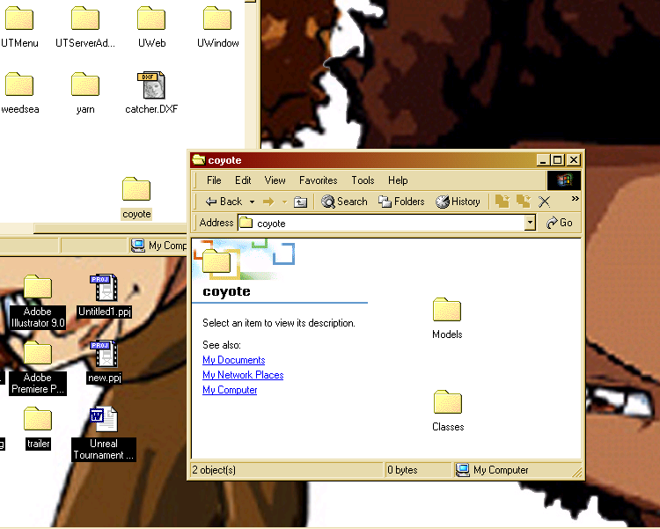
Fig 6. File organization

The .3DS file must be in the same folder as the 3ds2Unr executable. Run the executable, and type 3ds2Unr –setproj at the prompt.
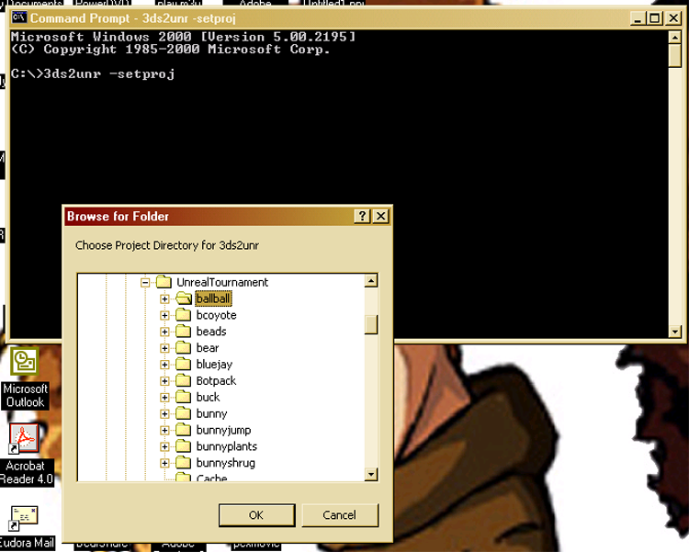
Fig 7. 3ds2Unr file organization

Browse directory and find folder in Unreal Tournament that was created with the name of mesh to be imported. Click OK.

Type ‘3ds2Unr name-of-mesh.3ds’ where name-of-mesh is appropriate. For example, 3ds2unr coyote.3ds would result in files converted for Unreal Ed importation to be processed by 3ds2Unr executable. If mesh adheres to all above restrictions, no warnings should be printed, and process should be completed successfully. If not, resort to 3dsMax model and modify it to adhere to aforementioned restrictions.

If pipeline through 3ds2Unr was successful, the following files should be created inside appropriate folders. The ‘Models’ folder should contain in addition to texture maps placed by user, two files named after that have ‘_a.3d’ and ‘_d.3d’ appended to file names. The ‘Classes’ folder should include an ‘.uc’ file titled after mesh name. 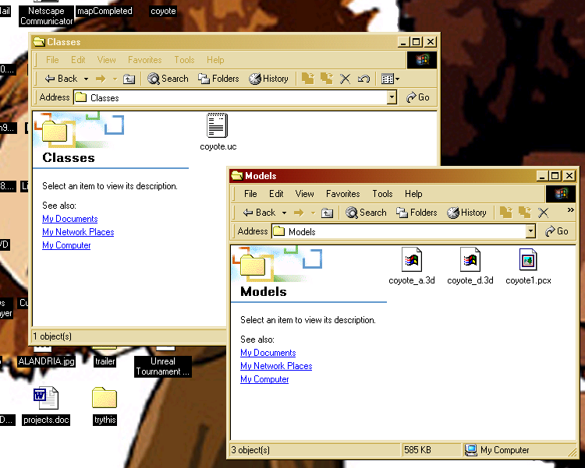
Fig. 8 Results of successful pipeline

If the model is static, (not animated) process is complete! However, if original file is an animated .3DS model, some trivial scripting is necessary. Locate .uc file inside ‘Classes file’ and open it using Notepad or other text editor. Append the following code to the bottom of the file:

event BeginPlay(){
loopAnim(‘name-of-mesh’);
}
where name-of-mesh is appropriate. 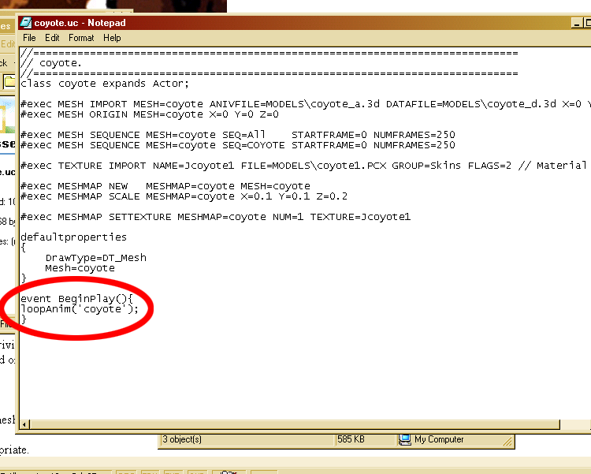
Fig9. Sample .uc File in Notepad

That process completes the 3ds2unr pipeline for even animated models.

III Importation from 3ds2unr into Unreal Ed

Scripting Unreal Compilation

The files created by 3ds2unr software must be compiled for use inside Unreal Editor. To compile the files created by 3ds2unr, trivial scripting must be done. Locate the ‘UnrealTournament.ini’ file found inside UnrealTournament>System folder. Open UnrealTournament.ini file using Notepad or some text editor. Hint: To find file, possibly all file extensions must be viewable.

Modify UnrealTournament.ini file by adding code below in section "Editor.EditorEngine" It may be best to search file for ‘Editor.EditorEngine’ to find this section, and scroll down to last statement of this section (sections are designated by an empty line between sections).
The .ini file will look like the following; add code in appropriate section...

[Editor.EditorEngine]
…other .ini statements in section
EditPackages=UTBrowser
[ADD CODE HERE]
EditPackages=name-of-mesh

Where name-of-mesh is appropriate, for example, statement will read ‘Editpackages=coyote’ to compile coyote mesh files.

Compilation process

Locate Command prompt. At prompt locate UnrealTournament>System folder by typing ‘cd’ for ‘change directory’ until inside appropriate folder. 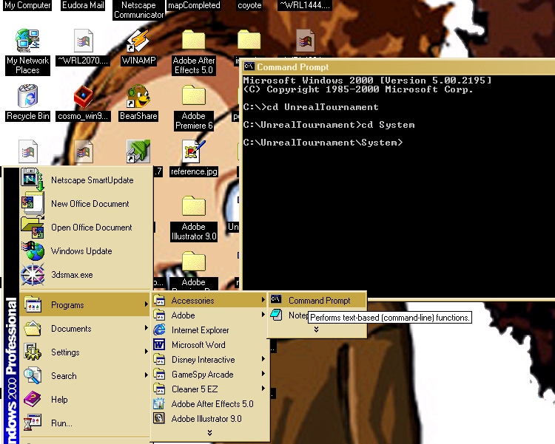
Fig 10 location to compile files

Once inside this folder, simply type ‘ucc make’ at prompt. And if process is successful, you have completed each stage in pipeline as directed, if not, please refer to above information and insure that above criteria have been met and limitations adhered to.

Referencing Imported model in Unreal Editor

The imported model, animated or static, is viewed by Unreal Editor and the game as an ‘actor.’ An ‘actor’ refers to a class in Unreal that may designate a specified item in the game level as benign and more or less decoration. The imported model and be found in the Actor Class Browser. Locate the Actor Class Browser by clicking the button that resembles a chess pawn or View>ActorClassBrowser…

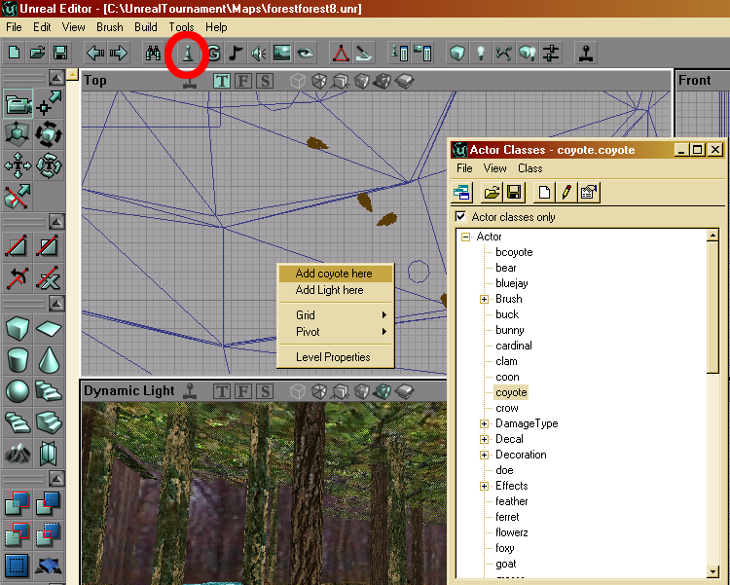
Fig 11. Referencing imported model

Highlight the name of the file when found in the list of ‘actors.’ Right click anywhere in the level and select to ‘Add name-of-mesh here,’ where name-of-mesh is appropriate.

